During the journey of spaceship from earth to moon and back, the maximum fuel consumed is:
A. Against the gravitation of earth in return journey.
B. Against the gravitation of earth in onward journey.
C. Against the gravitation of the moon while reaching the moon.
D. None of the above.
ANSWER: B

What is the acceleration due to gravity on the top of Mount Everest? Mount Everest is the highest mountain peak of the world at the height of $8848m$. The value at sea level is $9.80m/s^{2}$.
A. 9.773 $m/s^{2}$
B. 10$m/s^{2}$
C. 11 $m/s^{2}$
D. 12 $m/s^{2}$
ANSWER: A

The gravitational field is a conservative field. The work done in this field by moving an object from one point to another.
A. Depends on the end-points only.
B. Depends on the path along which the object is moved.
C. Depends on the end-points as well as the path between the points.
D. Is not zero when the object is brought back to its initial position.
ANSWER: A

In a manned satellite, people experience no gravity and it is known as
A. Gravity-weight
B. Gravitational weight
C. Weightlessness
D. Less-weight gravity
ANSWER: C

Gravitational field is a conservative field, hence work done is ___________ of path followed.
A. partially dependent
B. independent
C. dependent
D. both ‘a’ and ‘b’
ANSWER: B

The closed path is that whose initial and final position is _________.
A. Different
B. Same
C. zero
D. None of the above
ANSWER: B

Work done in close path in gravitational field is __________.
A. minimum
B. maximum
C. zero
D. both ‘a’ and ‘c’
ANSWER: C

A field in which the work is done in a moving a body along a closed path is zero is called
A. Electric field
B. conservative field
C. Electromagnetic field
D. Gravitational field
ANSWER: B

A field of force in which the work is independent of the path is called a _______________ field.
A. Electric field
B. conservative field
C. Electromagnetic field
D. Gravitational field
ANSWER: B

The gravitational field is a conservative field and work done depends on the
A. First point
B. Last point
C. End points
D. Mid points
ANSWER: C

The force that is not one of the conservative forces is
A. frictional force
B. gravitational force
C. electric force
D. elastic spring force
ANSWER: A

Which of the following types of force can do no work on the particle on which it acts?
A. Frictional force
B. Gravitational force
C. Elastic force
D. Centripetal force
ANSWER: D

For equilibrium, the net moment acting on the body by various conservative forces is _____.
A. One
B. Two
C. Three
D. Zero
ANSWER: D

What does Newton’s third law states for the conservative forces?
A. The rate of change of momentum is equal to the force applied
B. For every reaction, there is an opposite reaction
C. The body tends to be rotated if the force is applied tangentially
D. The body is rest until a force is applied
ANSWER: B

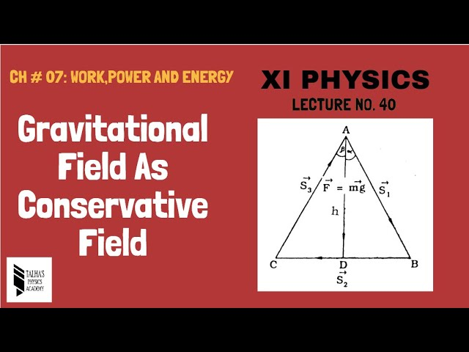
This figure shows a
A. Conservative field
B. Non-conservative field
C. Variable field
D. None of these
ANSWER: A

The work done on an object by the force of gravity __________ on the path taken to get from one position to another.
A. depends
B. does not depends
C. depends on two points
D. None of these
ANSWER: B

The work done on an object by the force of gravity depends on ______ taken to get from one position to another.
A. path
B. height
C. circle
D. None of these
ANSWER: B

Work done by gravity for horizontal displacement is ______ as force and displacement are at right angle.
A. Infinite
B. maximum
C. zero
D. None of these
ANSWER: C

Gravity is a _________ force.
A. variable
B. constant
C. negligible
D. None of these
ANSWER: C

The work done by the force of gravity on a satellite moving around the earth is ______.
A. zero
B. maximum
C. positive
D. negative
ANSWER: A

What is the work done by the force of gravity when a stone of mass 250 g is thrown up through a height of 2.5 m?
A. - 6.125 J
B. 6.125 J
C. 5 J
D. 7 J
ANSWER: A

The work done by gravity is
A. $W=F×d$
B. $W=mgh$
C. $W=mg$
D. $W= \int{F.d}$
ANSWER: B

The amount of work required to stop a moving object is equal to the?
A. Velocity of the object
B. Kinetic energy of the object
C. Mass of the object times its acceleration
D. Mass of the object times its velocity
ANSWER: B

One ______ equals the amount of work that is done when 1 N of force moves an object over a distance of 1 m.
A. kg
B. joule
C. second
D. pascal
ANSWER: B

Placing a suitcase on a luggage rack involves doing work against
A. potential energy
B. frictional force
C. gravity
D. none of these
ANSWER: C

The work done by gravitational force is ______ as gravitational force acts in downward direction and body displaces in opposite direction upward.
A. zero
B. negative
C. positive
D. none of these
ANSWER: B

Out of the following which quantity does not depend on path?
A. Temperature
B. Energy
C. Work
D. None of these
ANSWER: A

A _______ is a property whose value does not depend on the path taken to reach that specific value.
A. dynamic function
B. state function
C. path function
D. none of these
ANSWER: B

Work is a path dependent quantity. It is known as a ________ function.
A. dynamic function
B. state function
C. path function
D. none of these
ANSWER: C

For ______________ force work done is independent of path.
A. conservative
B. non-conservative
C. both a and b
D. none of these
ANSWER: A

